

**School of Mechanical & Manufacturing Engineering (SMME),**

**National University of Science and Technology (NUST),**

**Sector H-12 Islamabad**

AE-103

ENGINEERING DRAWING

ASSIGNMENT #3

AE-01

Due Date: May 14, 2024

Ayesha Ayaz (481761)

*Department of Aerospace Engineering*

*School of Mechanical and Manufacturing Engineering National University of Science and Technology*

*H12, Islamabad*

**Drawing #1**

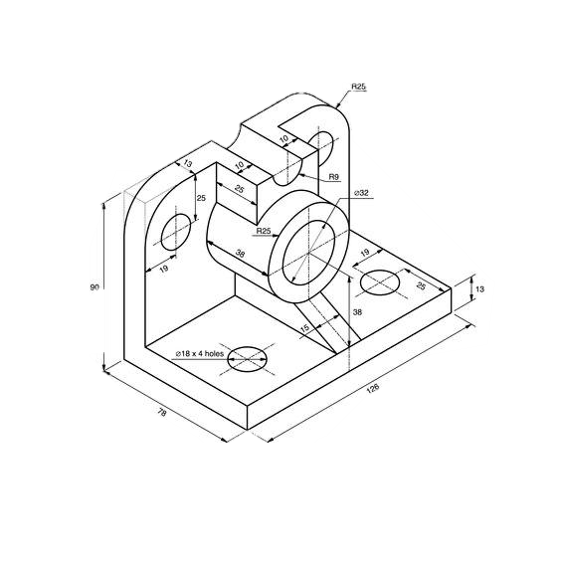Object 1

Front View

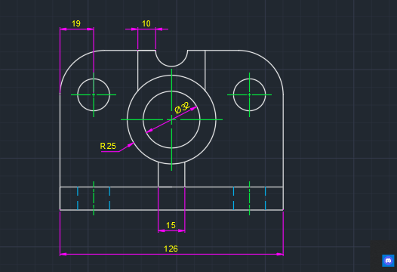

Side View

Top View

**Drawing #2**

Object 2

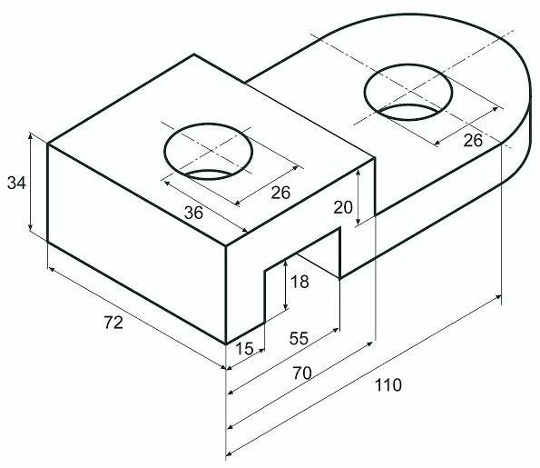

Front View

Side View

Top View

**Drawing #3**

Object 3

Front View

Side View

Top View

